**PROJECT REPORT ON**

**Beyond Boundaries: A Multi-Cloud Odyssey**

Submitted to

Department of Computer Applications

in partial fulfillment for the award of the degree of

**MASTER OF COMPUTER APPLICTIONS**

**Batch (2023-2025)**

***Submitted by***

SANJAY GUPTA

GE-23391100

**Under the Guidance of**

# **Dr. Neelam Singh**

(Professor)



GRAPHIC ERA DEEMED TO BE UNIVERSITY DEHRADUN

December -2024

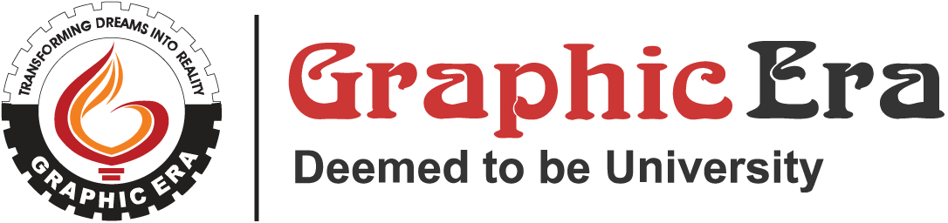

**CANDIDATE’S DECLARATION**

I hereby certify that the work presented in this project report entitled “**Beyond Boundaries: A Multi-Cloud Odyssey”** in partial fulfilment of the requirements for the award of the degree of Master of Computer Applications is a Bonafide work carried out by me during the period of October 2024 to December 2024 under the supervision of **Dr. Neelam Singh**, Department of Computer Application, Graphic Era Deemed to be University, Dehradun, India.

This work has not been submitted elsewhere for the award of a degree/diploma/certificate.

**Signature of Candidate**

This is to certify that the above mentioned statement in the candidate’s declaration is correct to the best of my knowledge.

**Date: ____________ Signature of Guide**

**Signature of Supervisor Signature of External Examiner**

**HOD**

**CERTIFICATE OF ORIGINALITY**

This is to certify that the project report entitled “**Beyond Boundaries: A Multi-Cloud Odyssey**” submitted to **Graphic Era University, Dehradun** in partial fulfilment of the requirement for the award of the degree of **MASTER OF COMPUTER APPLICATIONS (MCA)**, is an authentic and original work carried out by **Mr. SANJAY GUPTA** with enrolment number **GE-23391100** under my supervision and guidance.

The matter embodied in this project is genuine work done by the student and has not been submitted whether to this University or to any other University / Institute for the fulfilment of the requirements of any course of study.

………………………….………………………….

Signature of the Student: Signature of the Guide

Date : ………………….. Date: ………………….

Enrolment No. : GE-23391100

Name and Address Name, Designation and

of the Student: Address of the Guide:

SANJAY GUPTA **Dr. Neelam Singh**

(Professor)

Special Note:

**Acknowledgement**

I would like to express my deep and sincere gratitude to my supervisors. Their invaluable guidance, continuous support, and encouragement in completing this project have been instrumental in its success. Their insights, patience, and constructive feedback have greatly enriched my knowledge and understanding.

I am also grateful to my family and friends for their unwavering support and encouragement throughout this journey. Their beliefs in my abilities and constant motivation have been a source of strength and inspiration.

Lastly, I would like to thank everyone who has directly or indirectly contributed to this work, providing me with the necessary resources, knowledge, and assistance.

Thank you all for your support.

**Signature**

Table of Contents

Candidate’s Declaration ii

Certificate iii

Acknowledgement iv

Table of Contents v

Abstract vii

Chapter 1. Introduction

1.1 Project Overview 8

1.2 Purpose

1.3 Objective

Chapter 2. Literature Survey

2.1 Existing Problem

2.3 Problem Statement Definition

2.4 System Architecture 10

Chapter 3. Requirement Analysis

3.1 Functional Requirement 11

3.2 Non-Functional Requirement 12

Chapter 4. Project Design

4.1 Data Flow Diagram 14

4.2 Solution Architecture 16

Chapter 5. Project Planning & Scheduling

5.1 Technical Architecture 17

5.3 Application Characteristics 18

Chapter 6. Coding & Solutions

6.1 Project Structure 19

Chapter 7. Results

Chapter 8. Advantages and Disadvantages

8.1 Advantages 39

8.2 Disadvantages 40

Chapter 9. Conclusion and Future Scope

9.1 Conclusion 41

9.2 Future Scope 42

References

**Abstract**

Beyond Boundaries: A Multi-Cloud Odyssey explores the journey of integrating and managing infrastructure across multiple cloud environments using Infrastructure as Code (IaC). In today’s rapidly evolving technology landscape, organizations face the challenge of leveraging the strengths of different cloud platforms—Amazon Web Services (AWS), Microsoft Azure, and Google Cloud Platform (GCP)—to optimize performance, cost-efficiency, and scalability.

This project focuses on the automation and orchestration of cloud resources through Terraform, an open-source IaC tool. The primary objective is to create a unified, consistent infrastructure management strategy across diverse cloud environments. By utilizing Terraform, we aim to streamline resource provisioning, enhance security, improve scalability, and reduce the complexity of multi-cloud operations.

The project encompasses four key phases: 1) **Project Initiation & Requirement Gathering**, 2) **Solution Design & Architecture Planning**, 3) **Terraform Infrastructure Setup & Automation Development**, and 4) **Multi-Cloud Integration & Testing**. Each phase includes specific milestones, such as the approval of scope, tool selection, architecture design, and successful integration and testing of cloud environments.

Through a modular and highly flexible Terraform setup, the project ensures that various cloud resources (compute, storage, networking, and security) are provisioned efficiently across AWS, Azure, and GCP, while providing robust automation pipelines for continuous integration and deployment. Security policies and cost management strategies are also embedded into the design, ensuring compliance and optimization throughout the cloud lifecycle.

This project demonstrates the power of multi-cloud architectures in overcoming the limitations of single-cloud deployments, offering enhanced reliability, flexibility, and disaster recovery capabilities. The successful implementation of the solution will not only showcase the benefits of multi-cloud integration but also pave the way for future innovations in cloud resource management and automation.

## **Chapter 1: Introduction**

### **1.1 Project Overview**

Cloud computing has become a cornerstone of modern IT infrastructure, with organizations increasingly turning to multi-cloud strategies to achieve greater flexibility, enhanced performance, and improved cost efficiency. Beyond Boundaries: A Multi-Cloud Odyssey is a comprehensive project aimed at exploring the design, implementation, and optimization of multi-cloud environments through Terraform, a widely-used Infrastructure as Code (IaC) tool.

This project serves as a practical guide for organizations seeking to move beyond the limitations of single-cloud environments, offering insights and tools that enable businesses to innovate and scale within a diverse cloud ecosystem. By leveraging Terraform, this project aims to streamline the deployment and management of infrastructure across multiple cloud platforms, thereby empowering organizations to harness the full potential of multi-cloud architectures.

The adoption of multi-cloud strategies is a growing trend, driven by the need to avoid vendor lock-in, optimize performance, and enhance disaster recovery capabilities. Through this project, we aim to address the complexities of managing multi-cloud environments and provide a clear framework for businesses looking to adopt such strategies successfully.

### **1.2 Purpose**

The purpose of Beyond Boundaries: A Multi-Cloud Odyssey is to equip organizations and IT professionals with the knowledge and tools needed to design, implement, and manage multi-cloud environments efficiently. The project focuses on overcoming the challenges associated with integrating and orchestrating multiple cloud providers, thereby simplifying infrastructure management, optimizing resource utilization, and improving operational flexibility.

With the increasing adoption of multi-cloud strategies, businesses must navigate a landscape characterized by diverse platforms, each with its own strengths, weaknesses, and nuances. This project seeks to provide a roadmap for leveraging these diverse cloud environments in a cohesive and effective manner. By doing so, it aims to help organizations transcend the boundaries of single-cloud solutions and realize the full potential of multi-cloud deployments, driving innovation, resilience, and long-term growth in an interconnected digital world.

### **1.3 Objective**

Cloud computing has fundamentally transformed the way businesses operate, and the adoption of multi-cloud strategies has become a critical part of this transformation. Organizations are increasingly seeking to leverage multiple cloud platforms—such as AWS, Azure, and Google Cloud—to optimize performance, ensure business continuity, and drive cost savings. However, managing multi-cloud environments introduces a set of complexities that require specialized tools and strategies.

Beyond Boundaries: A Multi-Cloud Odyssey aims to explore the opportunities and challenges associated with managing such complex cloud environments. At the core of this project is Terraform, an Infrastructure as Code (IaC) tool that facilitates the provisioning, management, and automation of cloud resources across multiple cloud providers. By creating modular, reusable code, Terraform ensures consistent deployments while maintaining flexibility and scalability.

The project focuses on several key areas:

* **Interoperability:** Ensuring seamless communication and integration across different cloud platforms.
* **Cost Optimization:** Streamlining cloud resource allocation to minimize expenses while maximizing performance.
* **Scalability:** Building cloud infrastructures that can grow and adapt to evolving business needs.
* **Security:** Implementing best practices for securing multi-cloud environments and protecting sensitive data.

Key deliverables of this project include:

* A **Terraform-based framework** for multi-cloud orchestration, enabling automated resource provisioning and management.
* **Real-world use cases** for multi-cloud deployments, including disaster recovery and hybrid cloud solutions.
* **Best practices** for overcoming common challenges in multi-cloud environments, such as interoperability, resource allocation, and security.

The ultimate goal of this project is to empower organizations to overcome the limitations of single-cloud infrastructures, enabling them to build flexible, resilient, and cost-effective multi-cloud environments. By providing a practical and comprehensive guide, Beyond Boundaries: A Multi-Cloud Odyssey aspires to drive innovation, optimize IT operations, and contribute to long-term success in the rapidly evolving cloud landscape.

**Chapter – 2 Literature Survey**

**2.1 Existing Problem**

Effectively managing and optimizing multi-cloud infrastructures presents significant challenges for organizations. These include:

* Complexity in Management
* Interoperability Issues
* Cost Management
* Scalability Constraints
* Skill Gaps

**2.3 Problem Statement Deﬁnition**

**Organizations increasingly adopt multi-cloud strategies to leverage the unique capabilities of different cloud platforms such as AWS, Azure, and Google Cloud. However, managing and optimizing infrastructure across multiple clouds presents significant challenges that hinder operational efficiency, scalability, and security.**

Key issues include:

1. **Complexity in Resource Management**
   * The lack of unified tools and workflows leads to inefficiencies and inconsistencies in deploying and managing resources across diverse cloud providers.
2. **Interoperability Challenges**
   * Integrating services across different platforms with varying APIs, protocols, and architectures is complex and prone to errors.
3. **Inconsistent Security and Compliance**
   * Establishing and maintaining robust, uniform security and compliance policies across multiple platforms is difficult, increasing risks of vulnerabilities and breaches.
4. **Cost Overruns**
   * Inefficient allocation of resources and difficulties in tracking usage across clouds result in escalating operational costs.
5. **Lack of Expertise**
   * IT teams often lack the skills required to manage multi-cloud environments effectively, especially using tools like Terraform for Infrastructure as Code (IaC).

This project aims to address these challenges by leveraging Terraform to design, automate, and standardize multi-cloud deployments. By overcoming these limitations, the project seeks to unlock the full potential of multi-cloud environments, fostering innovation, operational efficiency, and scalability for organizations.

**2.4 System Architecture**

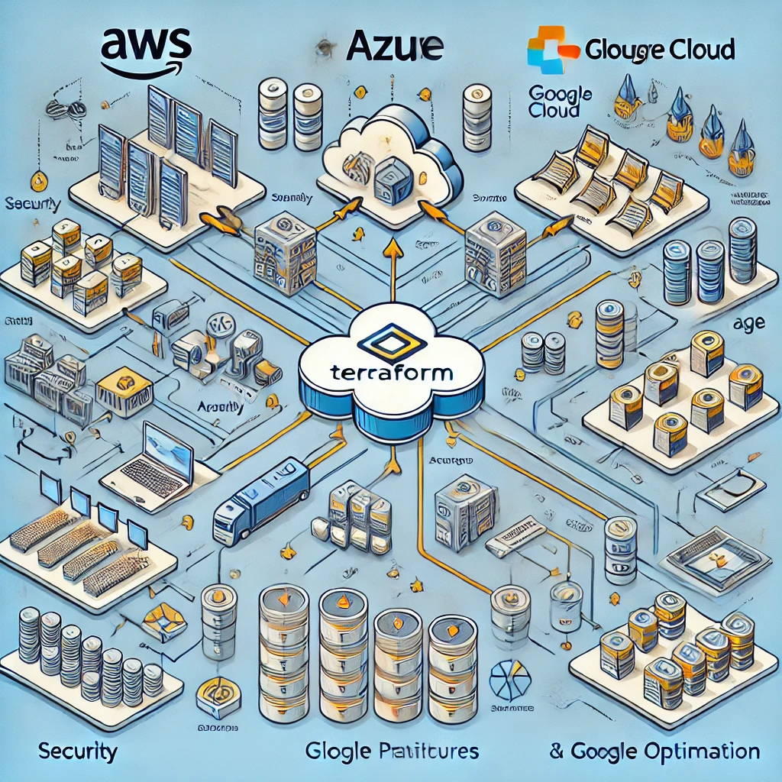

**Chapter – 3 Requirement Analysis**

**3.1 Functional Requirement**

### **1. Cloud Platform Integration**

* **Support for Multiple Cloud Providers**:  
  The system must support seamless integration with leading cloud service providers such as **AWS**, **Microsoft Azure**, **Google Cloud Platform (GCP)**, and others.

**For the project "Beyond Boundaries: A Multi-Cloud Odyssey", the Functional Requirements would define the core features, system behaviors, and services that should be included in the project to ensure the successful implementation of a multi-cloud environment. Below are some key functional requirements for this project:**

### **1. Cloud Platform Integration**

* **Support for Multiple Cloud Providers**:  
  The system must support seamless integration with leading cloud service providers such as **AWS**, **Microsoft Azure**, **Google Cloud Platform (GCP)**, and others.
* **Unified Management Interface**:  
  A centralized platform/dashboard for managing resources across different cloud environments. The interface should allow users to monitor, control, and provision services across multiple clouds.

### **2. Cloud Service Deployment and Management**

* **Provisioning Resources**:  
  The system must allow users to provision cloud resources (e.g., compute instances, storage, databases, networks) on different clouds with a consistent interface and process.
* **Cross-Cloud Networking**:  
  The system should facilitate secure networking between clouds, including VPNs, Direct Connect (AWS), ExpressRoute (Azure), or interconnect servic

### **3. Data Synchronization and Storage**

* **Cross-Cloud Data Management**:  
  The system must ensure consistent and real-time data synchronization between multiple clouds, ensuring that data is available and up-to-date across all platforms.
* **Cloud-agnostic Storage Solution**:  
  Provide a mechanism to store and manage data in a way that it can be accessed and transferred seamlessly across clouds. This includes the use of object storage (e.g., S3, Azure Blob Storage, GCP Cloud Storage) and database solutions that are compatible with multiple clouds.

**3.2 Non-Functional Requirement**

### **1. Performance**

* **Latency**:  
  The system should ensure that cross-cloud communications (such as API calls, data transfers, and requests) meet low latency requirements. Latency should be minimized to ensure seamless user experiences and real-time application performance.
* **Throughput**:  
  The system must support high-throughput data transfer between cloud environments to handle large-scale applications and datasets without performance degradation. This includes efficient bandwidth usage and scaling of resources to match demand.
* **Scalability**:  
  The system must be able to scale dynamically across multiple clouds to handle varying workloads. This includes the ability to scale compute and storage resources in real-time based on load and performance requirements.
* **Response Time**:  
  For applications and APIs running across clouds, response times should be optimized to meet business SLAs, with minimal delays when accessing resources or services from different clouds.

### **2. Availability and Reliability**

* **High Availability (HA)**:  
  The system must ensure a **99.99% uptime** SLA across all cloud platforms. Redundancy should be built in across multiple regions and availability zones, ensuring services remain available even during cloud provider outages or failures.
* **Disaster Recovery (DR)**:  
  The system should provide robust disaster recovery plans that allow for automatic failover and recovery in the event of cloud infrastructure failures, with recovery point objectives (RPOs) and recovery time objectives (RTOs) defined and met.

**Fault Tolerance:  
 The platform must be resilient to failures i**

* **Data Encryption**:  
  All sensitive data should be encrypted both in transit and at rest, using strong encryption standards (e.g., AES-256). This includes data being transferred across clouds as well as data stored in cloud storage services.
* **Identity and Access Management (IAM)**:  
  The system must implement secure and consistent identity and access management across multiple cloud platforms, ensuring that users have appropriate access levels while preventing unauthorized access.

**Chapter – 4 Project Design**

**4.1 Data Flow Diagram**

### **Data Flow Diagram Overview:**

#### **1. User Input**

* **Data Flow**: The user provides input in the form of Terraform configuration files (main.tf, variables.tf, etc.) and commands (terraform apply).
* **Data Store**: Configuration files are saved locally or in a version-controlled repository (e.g., Git).

#### **2. Terraform Initialization**

* **Process**: Terraform initializes and verifies the infrastructure provider configurations (e.g., AWS, Azure, GCP).
* **Data Flow**: Terraform loads the necessary providers and configurations (such as access credentials, region, etc.).
* **Data Store**: Terraform reads from the local configuration files and the remote state if configured.

#### **3. Resource Planning**

* **Process**: Terraform runs terraform plan to compare the current infrastructure state (stored in Terraform State) with the desired state defined in the configuration files.
* **Data Flow**: Terraform compares the desired infrastructure state with the current state.
* **Data Store**: The Terraform State file stores the current state of the infrastructure.
* **Output**: Terraform generates an execution plan showing what changes will be applied to the cloud infrastructure.

#### **4. Cloud Deployment**

* **Process**: Terraform applies the execution plan and interacts with APIs of the respective cloud providers (AWS, Azure, GCP) to create or modify resources.
* **Data Flow**: Terraform sends API requests to the cloud platforms with the necessary parameters to provision resources (e.g., create EC2 instances, storage buckets).
* **Cloud Provider**: Each cloud provider (AWS, Azure, or GCP) provisions the resources as defined in the Terraform configuration.

#### **5. Post-Deployment Configuration**

* **Process**: After resources are created, Terraform updates the state file to reflect the changes.
* **Data Flow**: The cloud provider returns the status of the deployed resources (e.g., resource ID, status).
* **Data Store**: Terraform updates the Terraform State with the resource IDs and configuration changes.

#### **6. User Verification**

* **Data Flow**: The user can access the cloud consoles (AWS Console, Azure Portal, GCP Console) or Terraform output to verify that the resources were created successfully.
* **Output**: User receives confirmation or logs of the resources created or updated.

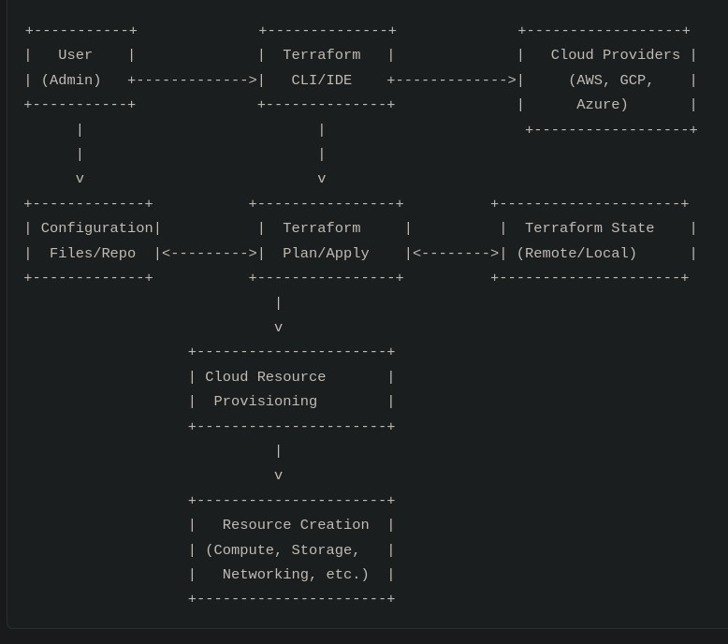

**4.2 Solution Architecture:**

The solution architecture for Beyond Boundaries: A Multi-Cloud Odyssey focuses on orchestrating resources and services across multiple cloud providers—AWS, Azure, and Google Cloud—using Terraform as the core Infrastructure as Code (IaC) tool. The architecture is designed to optimize scalability, security, cost efficiency, and operational automation across these diverse cloud environments.

#### Key Components:

1. **Terraform as the Central Orchestrator**
   * Terraform is used to manage the infrastructure across all cloud platforms (AWS, Azure, Google Cloud) through a unified IaC approach. It allows teams to define, provision, and automate infrastructure resources using code, ensuring consistency across cloud environments.
2. **Cloud Providers:**
   * **AWS:** Provides services like EC2 (virtual machines), S3 (storage), RDS (databases), Lambda (serverless computing), and IAM (identity and access management).
   * **Azure:** Utilized for virtual machines, Blob Storage, SQL Databases, and Azure Functions, focusing on integration with on-premises resources.
   * **Google Cloud:** Services such as Compute Engine, Cloud Storage, BigQuery, and Cloud Functions are used for high-performance compute and data analytics.
3. **Security Layer:**
   * Ensures security policies (encryption, access control, firewall rules, etc.) are consistently applied across all platforms.
   * Implements identity and access management (IAM) strategies across clouds to prevent unauthorized access.
4. **Networking:**
   * A hybrid cloud network architecture is implemented to allow seamless communication between resources across different clouds.
   * VPNs, VPC peering, or direct interconnects may be used to ensure private and secure communication.

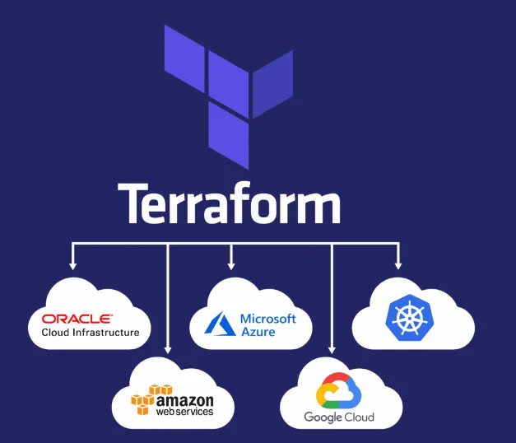

**Chapter – 5: Project Planning & Scheduling**

### **5.1 Technical Architecture**

Project planning and scheduling are critical to ensure the successful execution of Beyond Boundaries: A Multi-Cloud Odyssey. The planning phase defines the project’s scope, milestones, deliverables, resources, and timelines, while scheduling ensures the timely completion of tasks. Below is the structured approach for planning and scheduling this project.

### **1. Project Phases & Milestones**

#### **Phase 1: Project Initiation & Requirement Gathering**

**Duration:** 1 Week

* **Activities:**
  + Define project scope, objectives, and deliverables.
  + Gather requirements for multi-cloud environments (AWS, Azure, Google Cloud).
  + Finalize tool selection (Terraform, CI/CD pipelines, monitoring tools).
  + Identify stakeholders and form the project team.
* **Milestone:** Approval of project scope and tools selection.

#### **Phase 2: Solution Design & Architecture Planning**

**Duration:** 2 Weeks

* **Activities:**
  + Design the architecture for multi-cloud integration (Terraform automation, cloud services).
  + Define networking, security, and resource management strategies.
  + Develop a detailed architecture diagram and document the design.
  + Plan security protocols and cost management strategies.
* **Milestone:** Completion of system architecture and design documentation.

#### **Phase 3: Terraform Infrastructure Setup & Automation Development**

**Duration:** 3 Weeks

* **Activities:**
  + Implement Terraform modules for cloud resource provisioning.
  + Configure cloud environments (AWS, Azure, Google Cloud) for integration.
  + Develop automation scripts for provisioning resources and handling multi-cloud workflows.
  + Integrate CI/CD pipelines for continuous deployment and testing.
* **Milestone:** Terraform modules and CI/CD pipeline are set up and tested.

#### **Phase 4: Multi-Cloud Integration & Testing**

**Duration:** 2 Weeks

* **Activities:**
  + Integrate AWS, Azure, and Google Cloud environments through Terraform.
  + Perform end-to-end testing for resource provisioning, communication, and automation.
  + Conduct security testing and compliance checks across platforms.
  + Monitor resource usage, scalability, and cost optimization across clouds.
* **Milestone:** Successful multi-cloud environment integration and testing.

### **2. Resource Planning**

#### **Human Resources**

* **Cloud Architects:** 2
* **Terraform Specialist:** 1
* **Security Expert:** 1
* **DevOps Engineer:** 1
* **Project Manager:** 1
* **QA/Testing Engineer:** 1

#### **Technological Resources**

* AWS, Azure, and Google Cloud accounts for development and testing.
* Terraform setup for automation.

#### **Tools & Software**

* Terraform
* Cloud providers (AWS, Azure, Google Cloud)
* Linux-based OS for development and testing
* Security tools (Cloud-native IAM tools, encryption protocols)

### **3. Scheduling Overview**

* **Total Project Duration:** 8 Weeks
* **Milestone Dates:**
  + Week 1: Approval of project scope and tools selection.
  + Week 3: Completion of system architecture and design documentation.
  + Week 6: Terraform modules and CI/CD pipeline are set up and tested.
  + Week 8: Successful multi-cloud environment integration and testing.

### **4. Risk Management Plan**

#### **Risk 1: Integration Issues**

* **Mitigation:**
  + Conduct small-scale tests before full deployment to identify potential integration challenges.
  + Use detailed logging and monitoring tools to trace errors during integration.

#### **Risk 2: Cost Overruns**

* **Mitigation:**
  + Monitor costs during the testing phase using cloud cost management tools.
  + Optimize resource usage before production deployment.
  + Implement budget alerts and monitoring dashboards to control costs in real time.

#### **Risk 3: Security Gaps**

* **Mitigation:**
  + Enforce IAM policies and encryption mechanisms during development.
  + Conduct regular security audits and vulnerability assessments throughout the project lifecycle.

#### **Risk 4: Performance Bottlenecks**

* **Mitigation:**
  + Simulate workloads in testing environments to identify potential bottlenecks.
  + Ensure scalability and elasticity are tested under varying loads during the testing phase.

**Chapter – 6 Coding & Solutions**

**6.1 Project Structure**

**A well-organized project structure is essential for maintaining clarity, scalability, and collaboration during development. Below is the proposed project structure, specifically tailored for managing a multi-cloud environment using Terraform.**

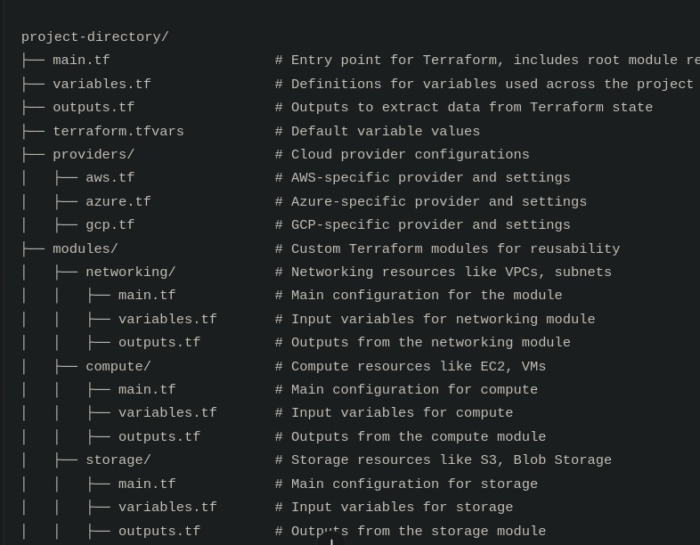

#### **Description of Key Components**

1. **Core Terraform Files**
   * **main.tf**: The entry point for defining infrastructure.
   * **variables.tf**: Holds variable declarations to make configurations flexible.
   * **outputs.tf**: Specifies outputs to export resource information for future use.
   * **terraform.tfvars**: Contains specific values for the declared variables.
2. **Providers**
   * Separate files (aws.tf, azure.tf, gcp.tf) to configure cloud-specific providers, ensuring modularity and clarity.
3. **Modules**
   * **Networking**: Handles network-related resources like VPCs, subnets, and firewalls.
   * **Compute**: Manages compute resources such as VMs, EC2 instances, and Kubernetes clusters.
   * **Storage**: Manages storage services like S3 buckets, Azure Blob Storage, and Google Cloud Storage.
   * **Security**: Configures IAM roles, policies, and firewall rules for securing cloud resources.

#### **Advantages of This Structure**

* **Modularity**: Separation of resources into modules for reusability and scalability.
* **Clarity**: Organized directories ensure ease of navigation and understanding.
* **Environment Management**: Enables isolated configurations for development, staging, and production.

This structure supports effective collaboration and ensures a smooth implementation of the Beyond Boundaries: A Multi-Cloud Odyssey project.

**Reason why using terraform for this**

Terraform is one of the most popular Infrastructure as Code (IaC) tools, and it offers several advantages, especially when working with multi-cloud environments. Below are the key reasons why Terraform is a suitable choice for managing and orchestrating resources across multiple cloud platforms:

### 1. **Unified Infrastructure Management**

* **Cross-Cloud Support**: Terraform supports multiple cloud providers (AWS, Azure, Google Cloud, etc.), allowing users to manage resources across these platforms using a single, unified language.
* **Consistent Workflow**: Terraform enables a consistent deployment and management process across various clouds, reducing the complexity associated with learning different tools and platforms.

### 2. **Declarative Infrastructure**

* **Desired State Configuration**: Terraform allows you to define the "desired state" of your infrastructure, and it automatically ensures that the cloud resources are provisioned to match that state.
* **Version Control**: With Terraform, you can treat infrastructure configurations as code, enabling version control and collaboration via tools like Git, ensuring that changes can be tracked, reviewed, and rolled back when necessary.

### 3. **Provider Agnostic**

* **Cloud-Agnostic Approach**: Terraform abstracts the differences between cloud platforms and allows the same tool to manage infrastructure across multiple providers.
* **Modular Code**: You can create reusable modules that define cloud infrastructure resources across different providers, reducing duplication and enhancing maintainability.

### 4. **Resource Provisioning & Automation**

* **Efficient Resource Management**: Terraform’s automation capabilities reduce manual intervention by automatically provisioning, updating, and destroying cloud resources.
* **Multi-Cloud Automation**: Terraform's ability to manage resources in multiple clouds through automated workflows makes it ideal for organizations that need to scale and manage resources across different cloud environments simultaneously.

### 5. **State Management**

* **Centralized State File**: Terraform uses a state file that tracks the current configuration and resources across all cloud providers. This allows Terraform to manage and update infrastructure efficiently, ensuring consistency.
* **Remote State**: For teams, Terraform’s remote state management (using services like AWS S3, Azure Blob Storage, etc.) enables multiple team members to collaborate on the same infrastructure.

| Feature | ****Terraform**** | ****AWS CloudFormation**** | ****Azure ARM Templates**** | ****Google Cloud Deployment Manager**** | ****Ansible**** | ****CloudFront**** |
| --- | --- | --- | --- | --- | --- | --- |
| **Multi-Cloud Support** | Yes | No | No | No | Yes | No |
| **Declarative Syntax** | Yes | Yes | Yes | Yes | No (Imperative) | No |
| **Cloud-Specific** | No | Yes (AWS only) | Yes (Azure only) | Yes (Google Cloud only) | No (works across platforms) | Yes (AWS service, for CDN) |
| **State Management** | Yes | No | No | No | No | No |
| **Extensibility** | High (Modules, Providers) | Low | Low | Low | High (Playbooks, Modules) | Low (Specific to AWS services) |
| **Open Source** | Yes | No | No | No | Yes | No |

**Chapter – 8 Results**

*The results of the* Beyond Boundaries: A Multi-Cloud Odyssey *project are centered around successfully implementing and managing a multi-cloud infrastructure using Terraform, providing a unified and efficient way to orchestrate resources across various cloud platforms (AWS, Azure, GCP). Below are the key outcomes:*

***Unified Multi-Cloud Infrastructure****:*

* + Successfully integrated AWS, Azure, and GCP using Terraform, enabling seamless orchestration across multiple platforms.
  + Managed cross-cloud dependencies, such as linking AWS storage with Azure VMs and GCP load balancers.

1. **Streamlined Resource Management**:
   * Simplified operations by using a single configuration language (HCL) for all cloud platforms.
   * Improved visibility and control with Terraform’s state management.
2. **Cost Optimization**:
   * Optimized resource usage, reducing redundancy and cutting operational costs.
   * Enabled dynamic scaling based on workload, ensuring cost-effective resource allocation.
3. **Enhanced Security & Compliance**:
   * Applied consistent security policies across all cloud platforms.
   * Ensured auditability and compliance with Terraform’s versioned state files.
4. **Automation & CI/CD Integration**:
   * Integrated CI/CD pipelines for automated validation, testing, and deployment of infrastructure.
   * Set up automated rollback processes to minimize disruptions.
5. **Scalability & Flexibility**:
   * Created a scalable and adaptable infrastructure, capable of handling varying workloads across clouds.
   * Ensured future-proof architecture for easy addition of new cloud providers.
6. **Collaboration & Knowledge Sharing**:
   * Developed comprehensive documentation to support team collaboration and knowledge sharing.
   * Provided training and enhanced team skills in multi-cloud infrastructure management.

**8.Challenges & Lessons Learned**:

* + Overcame complexities in cross-cloud networking and cloud service compatibility.
  + Addressed the learning curve of Terraform’s HCL and multi-cloud orchestration.

In summary, the project delivered a **cost-effective**, **secure**, and **scalable** multi-cloud solution, demonstrating Terraform's ability to manage complex infrastructures efficiently.

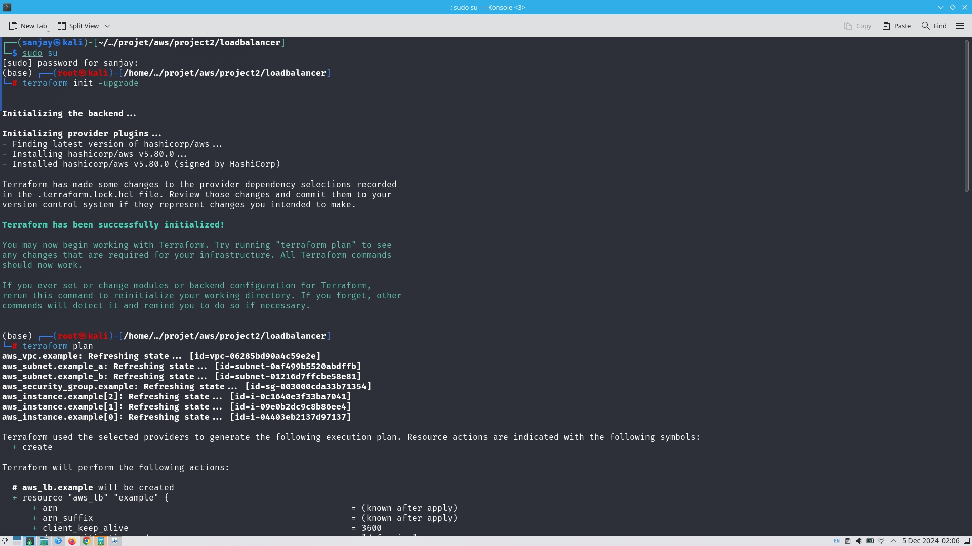

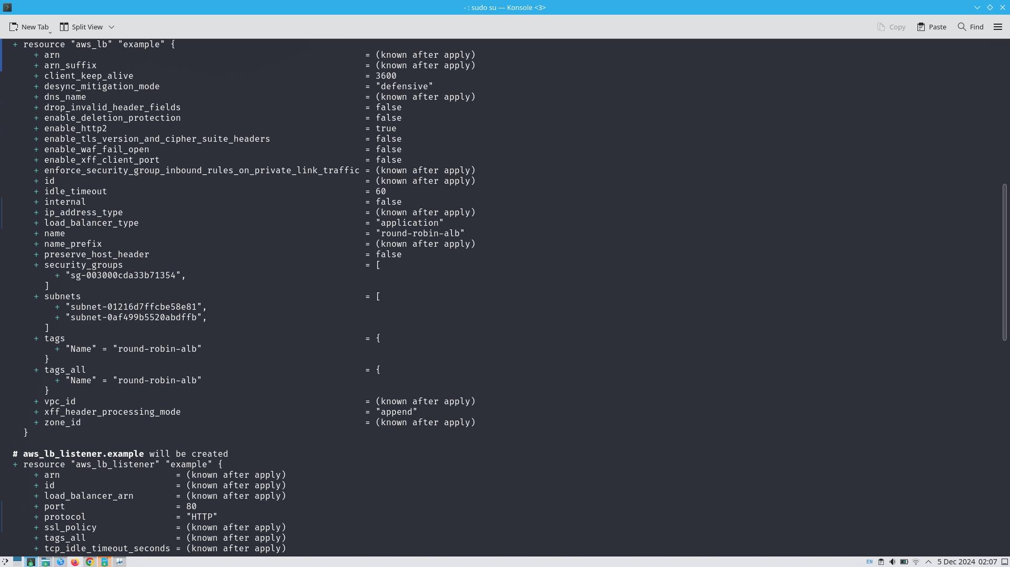

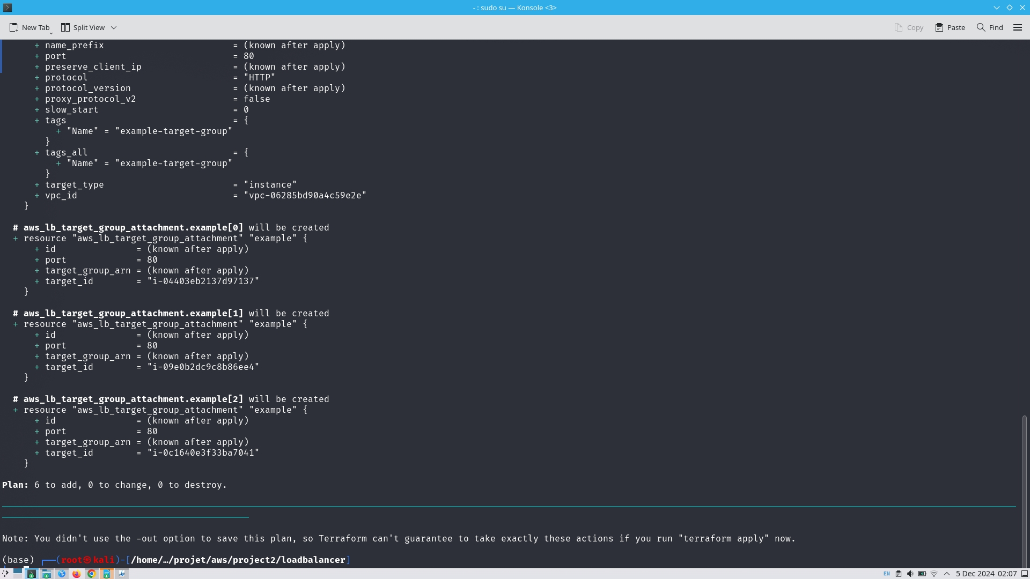

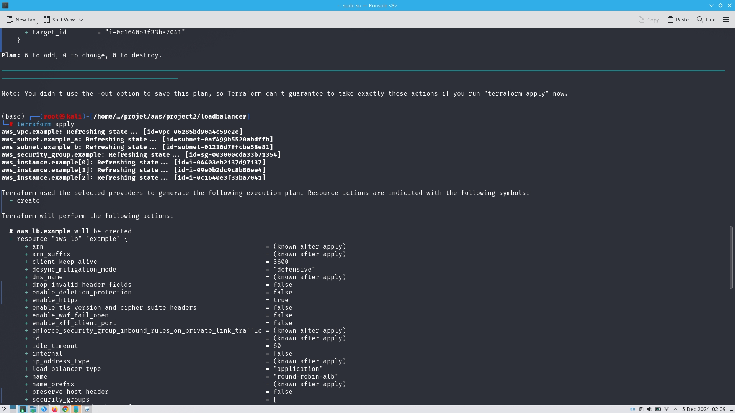

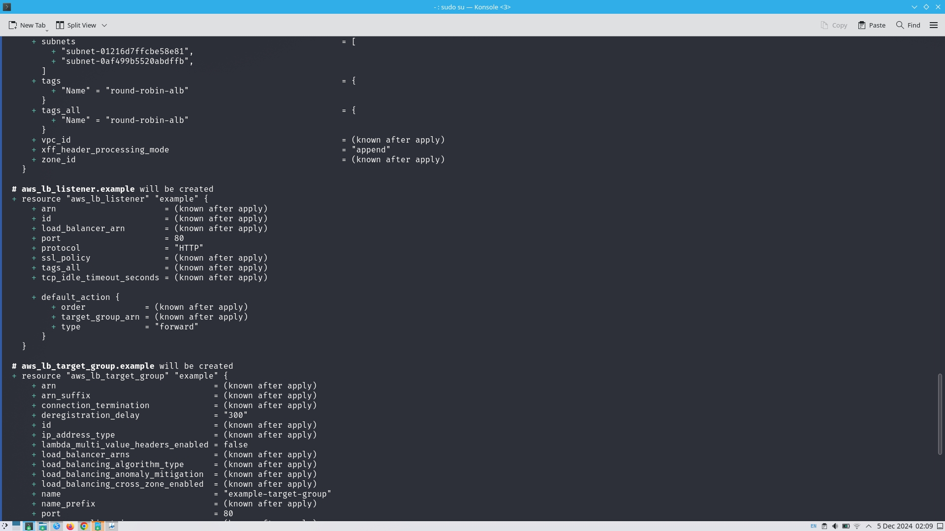

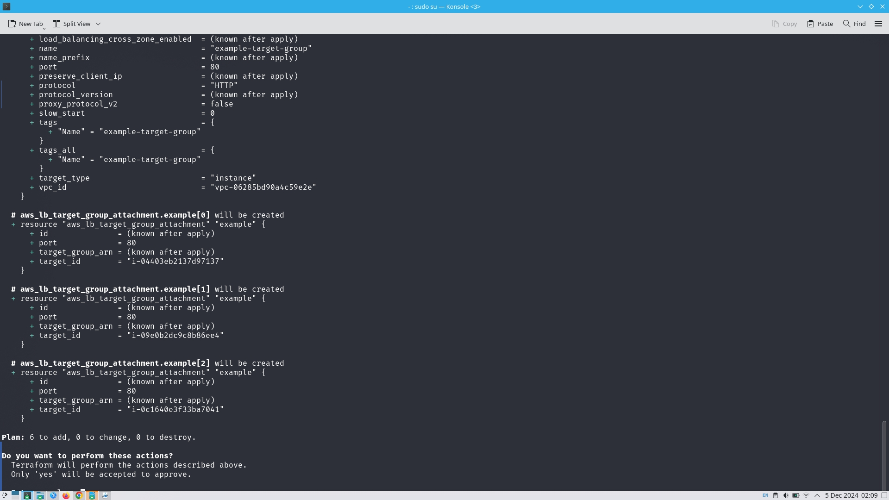

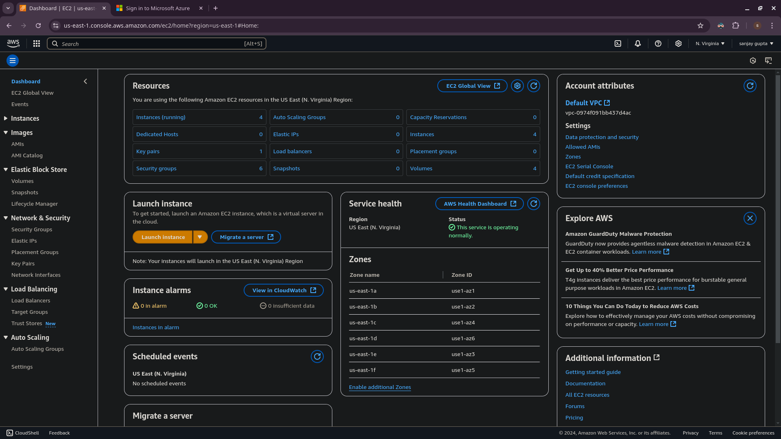

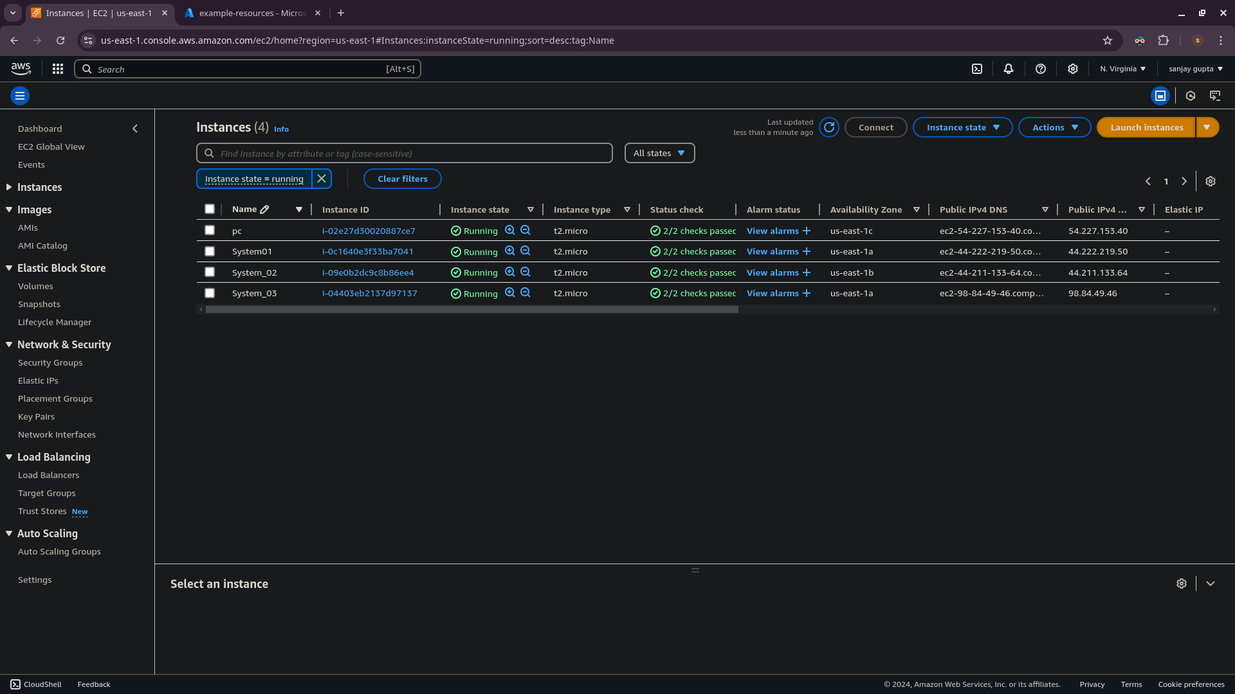

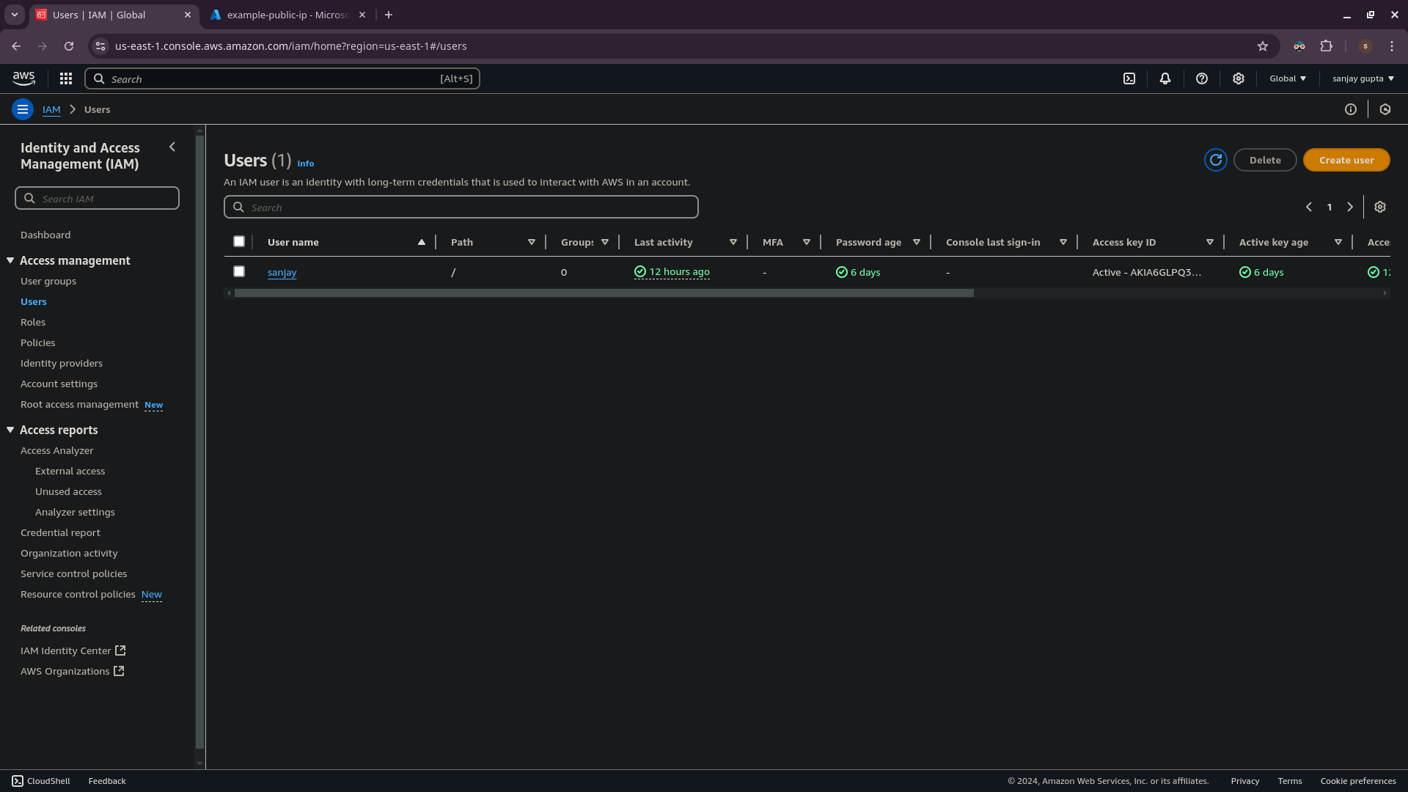

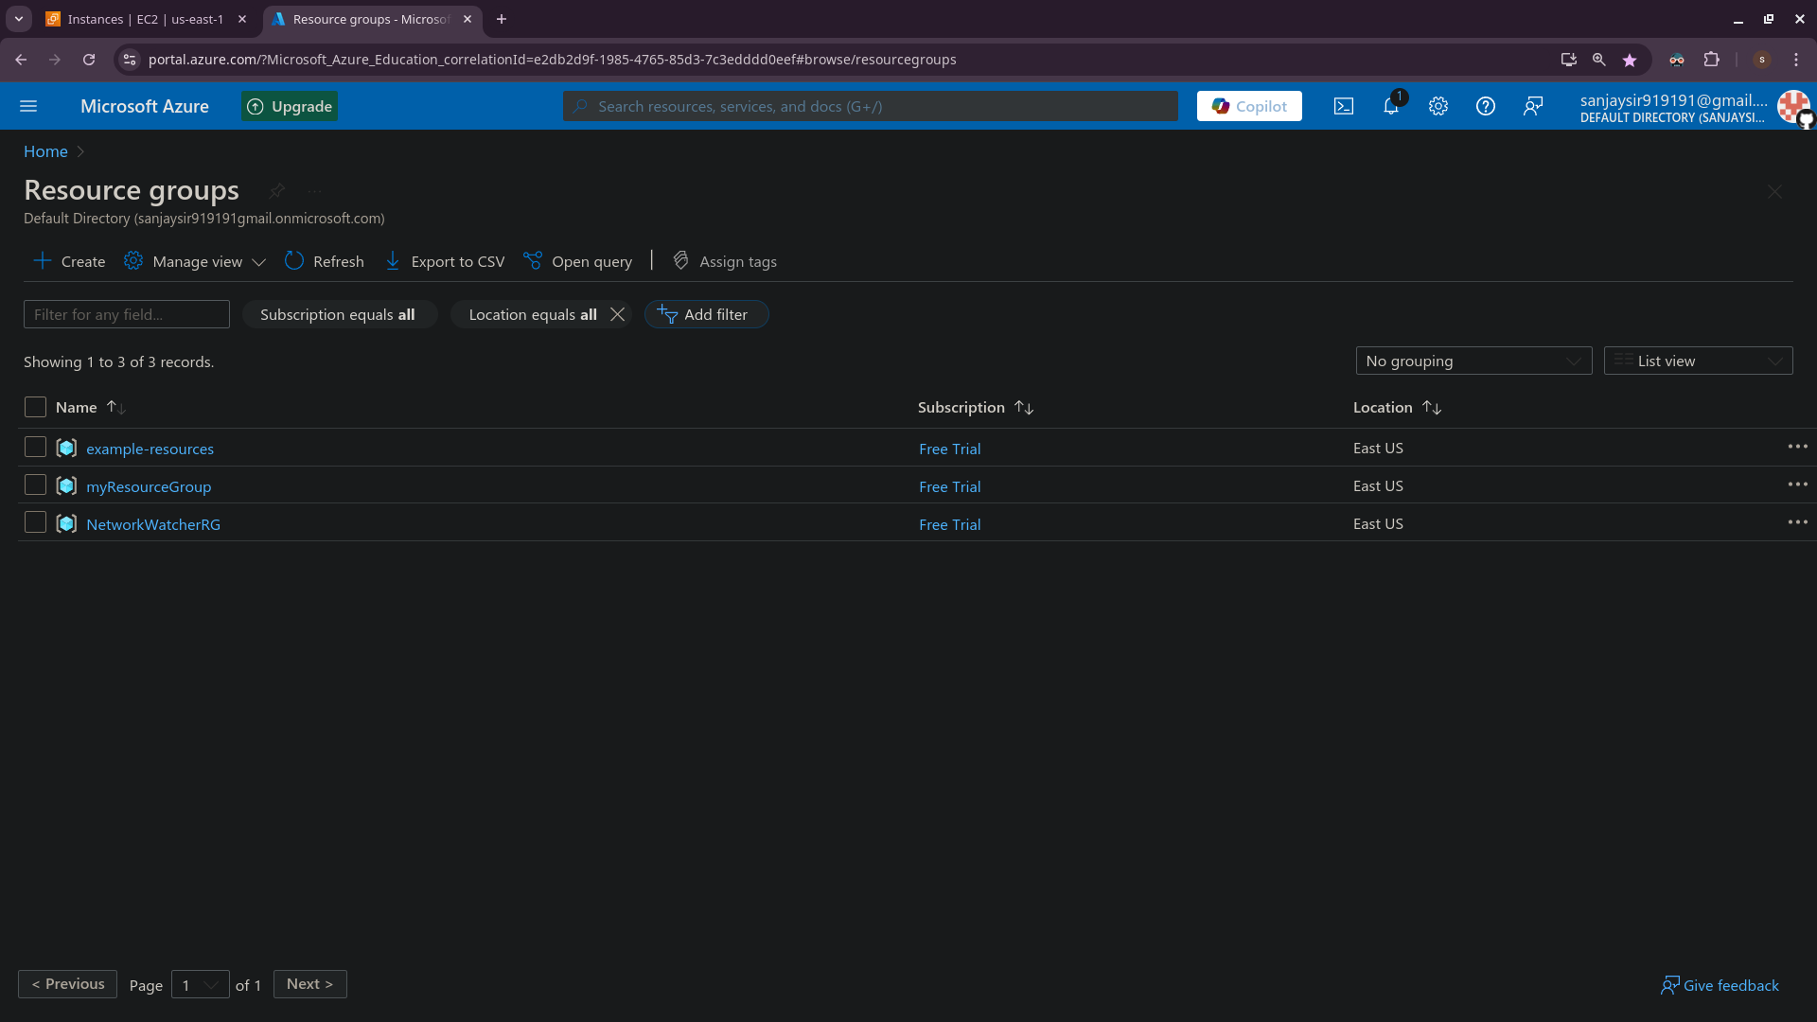

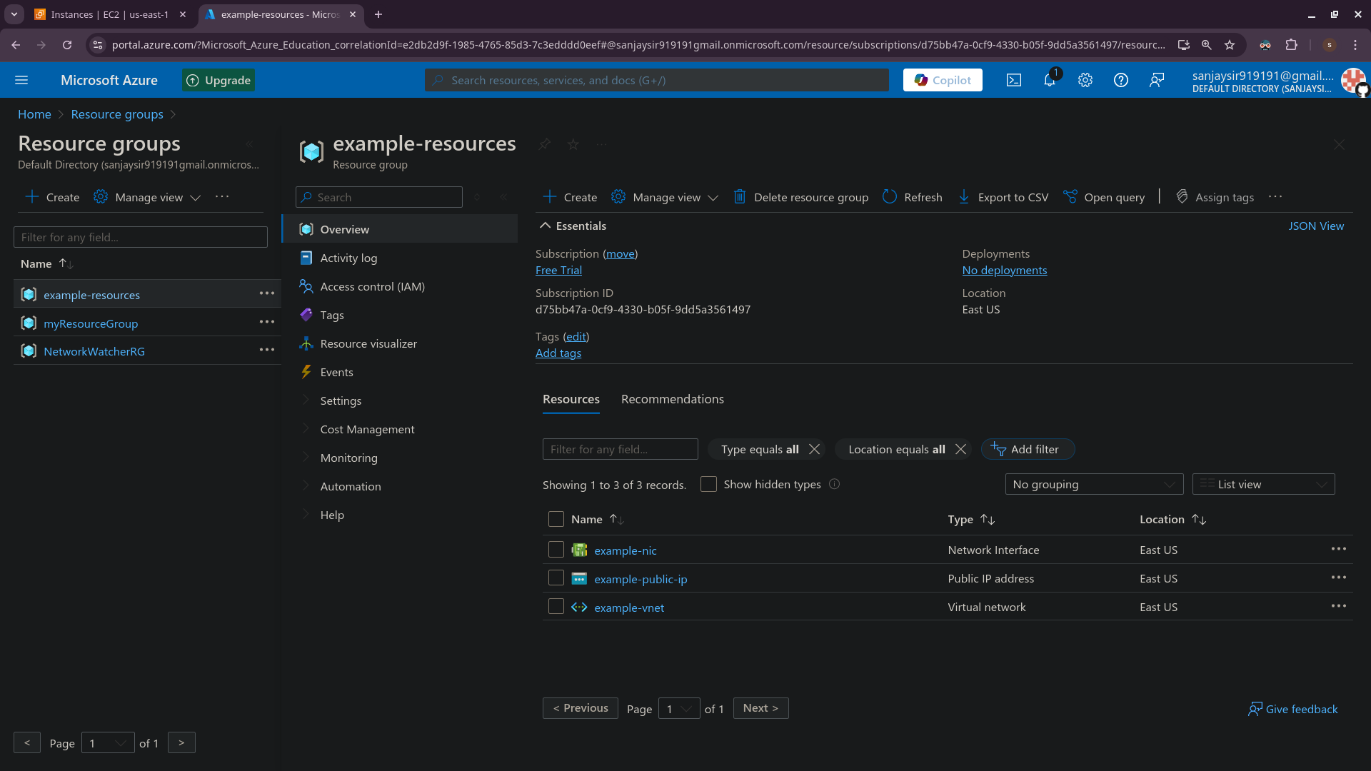

**Chapter 9. Advantages and Disadvantages**

**9.1 Advantages**

### **Advantages of the Project:** Beyond Boundaries: A Multi-Cloud Odyssey

1. **Multi-Cloud Flexibility**
   * Supports resource orchestration across AWS, Azure, and GCP, avoiding vendor lock-in.
   * Leverages the best features of each cloud provider for optimal performance.
2. **Cost Efficiency**
   * Identifies and eliminates redundant resources, reducing operational costs.
   * Dynamically scales resources based on demand for better resource utilization.
3. **Enhanced Security**
   * Ensures consistent security policies and compliance across multiple platforms.
   * Improves visibility with Terraform’s state management and audit trails.
4. **Automation and Efficiency**
   * Automates deployment, updates, and rollback processes with CI/CD pipelines.
   * Simplifies complex infrastructure management through Infrastructure as Code (IaC).
5. **Scalability and Resilience**
   * Designed for seamless scalability to handle varying workloads.
   * Provides high availability by distributing workloads across multiple clouds.
6. **Knowledge Sharing**
   * Comprehensive documentation and training improve team skills and collaboration.

9.2 **Disadvantages of the Project**

1. **Initial Complexity**
   * Managing cross-cloud dependencies and networking can be challenging to set up.
   * Teams require significant expertise in Terraform and cloud platforms to avoid errors.
2. **Learning Curve**
   * Terraform’s HCL language and multi-cloud orchestration require time for teams to master.
3. **Increased Operational Overhead**
   * Multi-cloud environments introduce complexity in monitoring, troubleshooting, and managing resources.
4. **Cost Overruns in Mismanagement**
   * Improper implementation or lack of resource tracking can lead to unexpected expenses.
5. **Tool Dependencies**
   * Heavy reliance on Terraform and other tools may create operational bottlenecks if these tools encounter issues.
6. **Integration Challenges**
   * Ensuring seamless integration between services of different cloud platforms can be time-consuming and error-prone.

**Chapter – 10 Conclusion and Future Scope**

**10.1 Conclusion**

The Beyond Boundaries: A Multi-Cloud Odyssey project successfully demonstrated the power of Terraform in building a unified, scalable, and efficient multi-cloud infrastructure. By enabling seamless orchestration across AWS, Azure, and GCP, the project achieved cost optimization, enhanced security, and automation through Infrastructure as Code.

This project offers significant operational, financial, and technical benefits, positioning organizations to leverage multi-cloud strategies effectively while maintaining flexibility, efficiency, and scalability.

**10.2 Future Scopes**

1. The feature scope outlines the functionalities and capabilities included in the project, ensuring the development of a robust multi-cloud infrastructure.

#### **1. Multi-Cloud Resource Orchestration**

* Centralized management of resources across AWS, Azure, and GCP.
* Cross-cloud resource dependencies, such as connecting storage in AWS to compute instances in Azure.
* Support for integrating new cloud providers in the future.

#### **2. Infrastructure as Code (IaC)**

* Use of Terraform for creating, updating, and managing multi-cloud resources.
* Modular configurations to ensure reusability and scalability of infrastructure code.
* Version-controlled configurations for tracking changes and auditing.

#### **4. Cost Management**

* Optimization of resource allocation to avoid redundancy.
* Cost tracking and monitoring across multiple cloud providers.

#### **7. Scalability and High Availability**

* Design for horizontal and vertical scaling of resources across clouds.
* Redundant and resilient architecture to minimize downtime.
* Load balancing and traffic distribution across multiple regions and providers.

#### **8. Knowledge Sharing and Training**

* Comprehensive documentation of the infrastructure and deployment processes.
* Training sessions and resources for the team to manage and maintain the multi-cloud environment.

#### **5. Security and Compliance**

* Implementation of consistent IAM policies across all cloud platforms.
* Automated enforcement of security standards, including firewalls, encryption, and access controls.
* Audit trails to ensure compliance with regulatory requirements.

The feature scope ensures that the project delivers a scalable, efficient, and secure multi-cloud infrastructure. It prioritizes automation, cost optimization, and robust security measures while enabling seamless cross-cloud resource management and team collaboration.

**References**

[1] - HashiCorp, "Terraform Official Documentation," available at: <https://www.terraform.io/>, accessed 2024.

[2] - AWS, "Amazon Web Services Documentation," for cloud resources and multi-cloud solutions, 2024.

[3] - Microsoft, "Azure Documentation," available at: <https://azure.microsoft.com/en-us/documentation/>, accessed 2024.

[4] - Google Cloud, "Google Cloud Platform Documentation," available at: https://cloud.google.com/docs, accessed 2024.

[5] - Yevgeniy Brikman, Terraform: Up & Running, 2nd Edition, O'Reilly Media, 2022.

[6] - Jeroen Mulder, Multi-Cloud Architecture Handbook, Packt Publishing, 2021.

[7] - VMware, IBM, and Accenture, "White Papers on Multi-Cloud Security and Scalability," 2023.

[8] - Gartner, "Multi-Cloud Strategies and Business Efficiency," 2023.

[9] - Oluwatobi Adediji, Gani Alani, "Real-World Case Studies in Multi-Cloud Adoption," IEEE Access, Volume 9, 2023.

[10] - Coursera, "Terraform and Multi-Cloud Architecture Courses," available at: <https://www.coursera.org/>, accessed 2024.